Master Thesis
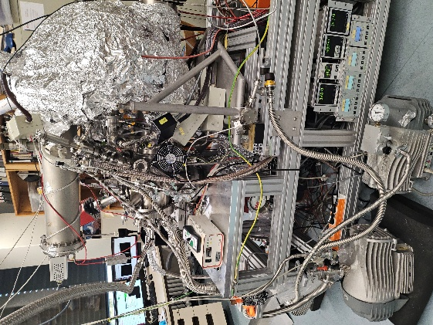 | In the Spectroscopy of Correlated Solid-state Materials Group, we use a novel photoemission technique - time-of-flight momentum microscopy - to analyse the structure and study the electronic band structures of modern correlated materials. Our measurements are carried out on crystals and thin films in the laboratory and at synchrotron facilities. Our aim is to gain a deep understanding of the causes of exotic macroscopic material properties by revealing peculiarities in the electronic structure. We are looking for motivated students to join our team as master students.
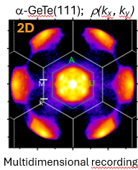
In our group you will gain experience with:
- State-of-the-art ultra-high vacuum technology;
- Sample preparation;
- Measurements with time-of-flight momentum microscopy in the
in the laboratory;
- Measurements at synchrotron facilities;
- Analysis of experimental data (XPD, XPS, ARPES).

Possible topics:
- Study of unconventional charge ordering in the Kagome systems;
- Strain-induced structural and electronic changes in TMDCs (transitional metal dechalogenides);
- Study of phase transitions in electronically correlated materials using inelastic scattering.
Depending on ongoing projects in the group, there may be other interesting topics for the master thesis, please contact us for updates.

Your profile:
- Independent and structured working style with good organisational and problem-solving skills;
- Interest in our research focus;
- Good knowledge of written and spoken English.

We offer:
- Trending scientific topics for your research;
- A friendly and supportive international team;
- An ideal opportunity to gain initial research experience and prepare for a possible future PhD.

Do you have any questions? Feel free to contact us!
If you are interested, we look forward to your e-mail to Fedchenko@physik.uni-frankfurt.de.

Useful links to this topic:   | 