PhD Thesis
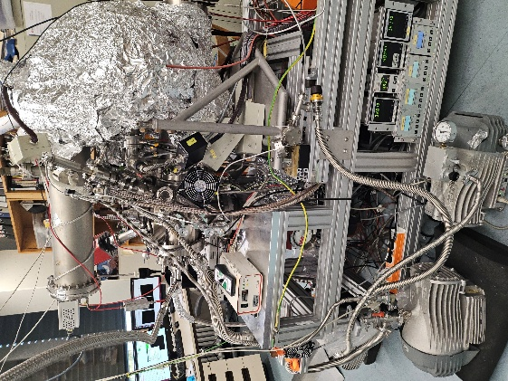 | In the Spectroscopy of Correlated Solid-state Materials Group, we use a novel photoemission technique - time-of-flight momentum microscopy - to analyse the structure and study the electronic band structures of modern correlated materials. Our measurements are carried out on crystals and thin films in the laboratory and at synchrotron facilities. Our aim is to gain a deep understanding of the causes of exotic macroscopic material properties by revealing peculiarities in the electronic structure. We are looking for motivated people to join our team as PhD students.

In our group you will gain experience with:
- State-of-the-art ultra-high vacuum technology;
- Experimental data analysis (XPD, XPS, ARPES, MOKE);
- Sample preparation for the surface sensitive photoemission experiments;
- Operation of the time-of-flight momentum microscopy setup;
- Operation of magneto-optical Kerr microscope (MOKE);
- Measurements at synchrotron facilities (soft and hard X-ray beam lines);
- Writing of scientific papers and presenting of the experimental results at international conferences;

Possible topics:
- Investigation of inversion symmetry breaking in electronically corelated materials with inelastic scattering in transmission time-of-flight momentum microscopy;
- Operando angle-resolved photoemission spectroscopy (ARPES) of heterostructures and devices on the base of them;
- Standing Wave X-ray Photoelectron Spectroscopy for Multilayered Systems;
- Spin and angle-resolved photoemission spectroscopy (ARPES) of electronically corelated materials;
If there is no open position within running projects in the group we are always open to discuss joint funding applications.

We offer:
- Trending scientific topics for your research;
- A friendly and supportive team;
- An ideal opportunity to gain initial research experience and prepare for a possible future PhD.
- work in international environment and the opportunity to interact with a world wide network of collaborators.
Your profile:
-Some experience with photoemission experiements and/or
Independent and structured working style with good organisational and problem-solving skills;
- Interest in our research focus;
- Fluent written and spoken English.

